FANUC 0M MANUAL

Utils

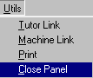

Tutor Link
If you have a Denford Desktop tutor connected to the computer select this option to switch control away from the on-screen tutor. Select this option again to switch control from the desktop tutor back to the on-screen tutor.

Machine Link
If you have a Denford CNC machine tool connected to your computer select this option to drive the machine directly from the on-screen control, or from the Denford Desktop Tutor.

Print
Outputs a hardcopy of the MDI panel to the printer.

Close Panel
Closes the on screen Tutor and returns control to the main CNC editor.
Upload CNC programs

Any CNC programs can be uploaded into the CNC control. Select load CNC program from the main menu. This can be a CNC program stored in the default directory or a CNC program from any other source.

The CNC program will be displayed in the CNC editor and you will be prompted to enter  mode and to press the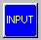 button.

Once the CNC program is in the CNC editor you can upload the program at any time.

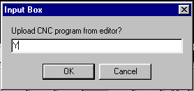

Type in 'Y' to confirm the upload. The CNC program will be displayed in the controls memory.

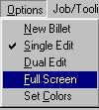
If the CNC editor is not hidden automatically you can hide the CNC editor again by selecting Full Screen from the Options Menu.

Edit

Select Edit mode to....
1 - write or change a CNC part program.
2 - to load, save and delete CNC part programs.

Use the 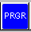 PRGR button to switch between editing a CNC program or listing all the CNC files.
MDI

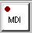 Switches to MDI mode. Press the button to display the MDI screen if it is not already displayed.

MDI screen

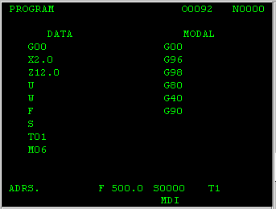

Use the MDI display to manually enter a single block of CNC information. This can be used to change tools, feed rates, single block moves or to call M codes for example to switch the spindle off/on.

Enter a CNC block of information at the ADRS. line and press the button to send it to the MDI screen.

Example M06 G00 T01

Press the  button to execute the CNC block.

Auto

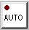
To run any CNC part program displayed in the Fanuc CNC editor you need to be in Auto Mode.

Execute from first CNC block.

In Edit Mode make sure the cursor is on the first line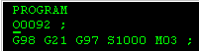 in the CNC editor by scrolling up using the  or by pressing the  button.

Home


If the CNC machine your control is connected to has datum switches you can send the axes to their home positions.

Use the 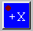,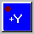,  keys to send each individual axis to it's home position.

Machine Control
When connected to a CNC machine tool wait until the axes have stopped moving before executing another control command.

Jog

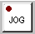
Jog mode allows continous movement of the axes at a set feed rate or at the fast traverse feed rate.

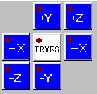
Press any of the axes keys for continuous movement.

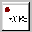 Toggles between feed rate and fast traverse movement. To set the feed rate use the MDI screen.

Inc Jog

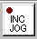
Inc Jog mode allows movement of the axes at a fixed distance. This distance is set by the three buttons below.

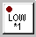 Sets the distance to 0.01mm / 0.001ins

Sets the distance to 0.10mm / 0.010ins

Sets the distance to 1.00mm / 0.100ins

Press any of the axes keys to jog an axis.

POS

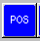 Displays the axes positions for the X,Y and Z axis.

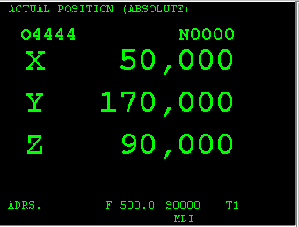

You can switch to this screen during program execution.
Offset

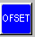 Toggles the display between the tooloffset and workshift pages.

Tool Offsets
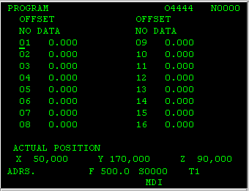

WorkShift Offsets
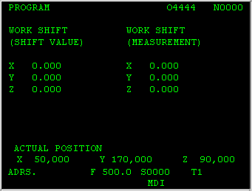

Ofset Mesur

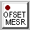 Pressing the offset measure takes a snapshot of the current axes positions to be used when you are going to set a tooloffset or workshift value. If you are setting each axis individually you need to press this button for each axis position. If you want to set all axes move the tool to the datum position on all axes then press this button to store the current positions.

You should have selected the tool offset or workshift page with the offset button.

PRGR button

In Edit Mode the PRGR button switches the display between listing a CNC program or listing all the CNC files.

In all other modes a display of the CNC program will be shown.

You can switch the display during program execution.

INPUT

Depending on the current mode INPUT has several uses.

1 - Entering data in MDI mode.

2 - Setting Tool Offsets.

3 - Setting Workshift Offsets.

4 - Uploading CNC programs from the CNC editor.

OUTPT START

Select mode if not already selected.

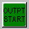 Press this button to download the current CNC program in the controls memory to the CNC editor.

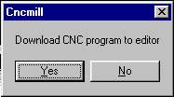

Type in 'Y' to confirm the download. The CNC editor will display the downloaded program.
To hide the CNC editor again select Full Screen from the Options Menu.
Setting WorkShift Offsets

Press the Offset button to display the workshift page , you may have to press the button twice to switch between tool offsets page and workshift page.

You should have jogged your tool to the correct position for setting the workshift values, normally the bottom lefthand corner of the billet for the X and Y axes and the top of the billet for the Z axis.

Press the offset measure button the lcd light should flash on then off.

Setting the Y axis

Type in MY0 at the ADRS. line and press the button, the workshift value should be displayed in the workshift page.

Setting the X axis

Type in MX0 at the ADRS. line and press the button, the workshift value should be displayed in the workshift page.

Setting the Z axis

Type in MZ0 at the ADRS. line and press the button, the workshift value should be displayed in the workshift page.
CYCLE START

Cycle Start is used to start or restart the execution of a CNC program.
You must be in mode to execute the current CNC program in the controls memory.

Press to restart program execution when using 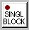.

Press to restart execution when using .

Press to execute single commands from the MDI screen.
You must be in mode to execute single commands.

CYCLE STOP

 Pauses program execution. Press the button to restart.

RESET

Pressing the button in mode stops program execution.
BLOCK DELETE

 Any CNC block that starts with a block delete character '/' will be ignored if the button is active.

Example: /M00
During program setup you may want a program stop to be executed by including a 'M00' as a CNC block.
After setup you can tell the control to ignore the program stop by making the button active.

OPT STOP

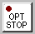 If the Opt Stop button is active and a 'M01' block is programmed the control will stop execution until the button is pressed.

A M00 block will stop program execution whatever state the Opt Stop is set to.

PROG STOP

 Instructs the control to stop program execution after the current line has been executed.

Press to restart program execution.

SINGL BLOCK

You can select this option during or prior to program execution. Once activated the control will stop program execution at the end of each machining line or cycle.

Press to restart program execution.

You can switch single block simulation off by pressing the button again.
Coolant Commands

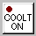Switches the coolant on.

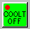Switches the coolant off.

Spindle Commands

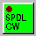Switches the spindle on with clockwise orientation.

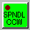Switches the spindle on with anti-clockwise orientation.

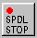Switches the spindle off.

 Increases the spindle speed up to the maximum allowed spindle speed.

 Decreases the spindle speed.
Setting Tool Offsets

Press the Offset button to display the tool offsets page , you may have to press the button twice to switch between workshift page and offset page.

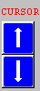Use the cursor keys to move the cursor to the tool offset number that you want to set.

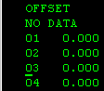For example offset number 3.

You should have jogged your tool to the correct position for setting the Z length offset normally the top of the billet on the Z axis.

Press the offset measure button the lcd light should flash on then off.

Setting the Z axis

Type in MZ0 at the ADRS. line and press the button, the offset value should be displayed in the tool offset page.

Display Files

All CNC programs uploaded into the control from the CNC editor or entered into the control by the keypad, are stored in the controls filing system.

To display the files select then press the button.

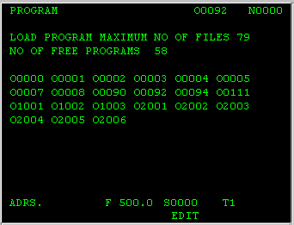

Loading Files

If the files are not yet displayed then select then press the button to display all files.

Type in a program name at the ADRS line 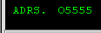 Make sure the program name starts with the letter 'O'.

Press the cursor down button to load the CNC program into the controls memory.

Repeat the above without showing the list of files if you already know the name of the CNC program.

Scroll CNC programs

You can scroll through the CNC programs by typing in 'O' at the ADRS line and pressing the cursor down button. Repeat again to view the next CNC program.

Starting a New CNC program

To start a new CNC program select and press the button if you want to check the list of file names that are already in use.

Enter a new filename at the ADRS line. and press the 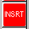 button to confirm.

The controls memory will be cleared and the selected program name will be the first line of the program.

Example 1 : 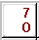 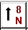

This would display the following 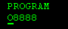

Example 2 : 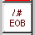

This would display the following 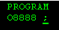

Deleting CNC programs

To delete a CNC program select and press the button to view the list of file names.

Type in the name of the filename that you want to delete at the ADRS line.

and then press the 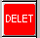 button. The file listing will be updated with the deleted file no longer displayed.
Adrs Line

Use the address line to enter a word of information. All information must be entered at the address line.

A word of information always starts with a letter followed by a numerical value.

Example: G00
X12.345
M06

To enter any value you use the controls keypad.

Alpha Numeric Keypad

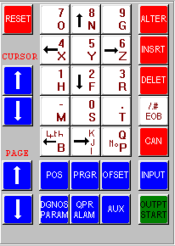All CNC programs can be entered using the controls keypad.

To enter a new word make sure the address line is empty. Press the 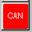 key to clear the address line if required.

To enter G01 press the following keys

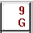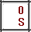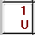

To enter X-12.45 press the following keys

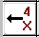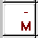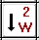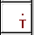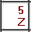
Insert/Edit a CNC program

To insert or edit a CNC program you must follow the correct procedures that are compatible with the Fanuc 0M control.
All words of information are entered on the address line and then inserted using the button.
All blocks of information are made up of several words, and end with an end of block character.

Press this button to enter an EOB character.

The position of the edit cursor dictates where the next word will be inserted in the editor.

Use the keys to move the edit cursor to the correct position.
Adding new words

Inserting a Feed after the Y value

Move the edit cursor to the Y letter.
G00 X 121.45 Y 10.5 ADRS F300

G00 X 121.45 Y 10.5 F300

Inserting an EOB character

Move the edit cursor to the F letter.

G00 X 121.45 Y 10.5 F300 ADRS

G00 X 121.45 Y 10.5 F300 ;

Starting the next line

Move the edit cursor to the EOB character.
G00 X 121.45 Y 10.5 F300 ; ADRS G02

G00 X 121.45 Y 10.5 F300 ;
G02

Using the EOB character

Splitting a line using the EOB character

Move the edit cursor to the F letter.

G00 X 12.45 Y 10.23 F300 M06 T01
ADRS ;

G00 X 12.45 Y 10.23 F300 ;
M06 T01

Inserting a new line using the EOB character

Move the edit cursor to the EOB character.

M03 S2300 ;
G01 X 12.3 Y 10.2 ;
ADRS G00

M03 S2300 ;
G00 ;
G01 X12.3 Y 10.2 ;

Deleting words/blocks

Deleting a word

Move the edit cursor to the Y letter you want to delete.

G00 X 12.45 Y 12.44 F 455 ; Press the button.

G00 X 12.45 F 455 ;

Deleting an EOB character

Move the edit cursor to the EOB character.
G00 X 12.45 Y 12.44 F 455 ;
M03 S2345 ;
Press the button.

G00 X 12.45 Y 12.44 F 455 M03 S2345 ;

Cursor keys

If the ADRS line is empty pressing the cursor keys will move the edit cursor up/down in the editor, one word for each key press.

If the ADRS line contains text the cursor keys will search in the editor for the text. If text is found the editor will scroll to the new position.
Pressing the up arrow will enable the search towards the start of the CNC program.
Pressing the down arrow will enable the search towards the end of the CNC program.

You can be in mode or mode to start a search.

ALTER

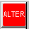 To change a word of information that has already been entered in the editor.

1 - Move the cursor to the word that you want to change.

2 - Enter the new word at the address line.

3 - Press the key. The new word will be displayed in the controls memory.

DELET

To delete a word of information.

1 - Move the cursor to the word that you want to change.
2 - Press the key. The word will be deleted from the controls memory.

Deleting the EOB character from the end of a block will add the next block to the end.

Cancels the current information on the address line.
INSERT

To enter a new word of information into the controls memory.

1 - Key in the new word at the address line.

2 - Move the cursor to the correct position in the editor.

3 - Press the key to enter the new word.

EOB

This key is used to enter an end of block character.

Example G00 X12.45 M03 S2000 ;

A block is a series of words with the end of block character at the end.

Press the key to enter the end of block character in the editor.

RESET

Moves the cursor in the editor to the start of the program.

You must be in mode.

Pressing the button in mode stops program execution.

